Paper 1

1 | D | 7 | B | 13 | B | 19 | B | 25 | B
2 | A | 8 | D | 14 | B | 20 | B | 26 | C
3 | D | 9 | C | 15 | C | 21 | C | 27 | D
4 | C | 10 | D | 16 | B | 22 | A | 28 | A
5 | A | 11 | B | 17 | D | 23 | A | 29 | C
6 | D | 12 | D | 18 | A | 24 | A | 30 | B

Paper 2

1 | Sodium peroxodisulfate, Na₂S₂O₈, is commonly used as a bleaching agent in hair cosmetics.
 | (a) | Given that peroxodisulfate oxidises iodide solution to form black crystals, while it is reduced to form SO, construct a balanced equation.
 |  | S₂O₈²⁻ + 2I⁻ → 2SO₄²⁻ + I₂
 | A quality control experiment was set up to monitor the current level of peroxodisulfate in the air of the laboratory to ensure that it does not reach hazardous levels (above 1000 mg dm⁻³).
 | (b) | 25 cm³ of air was bubbled into 250 cm³ of water and 25 cm³ of this solution was taken to titrate against a standard solution of potassium iodide, with known concentration of 0.0025 mol dm⁻³.
 |  | (i) | Assuming that all of the peroxodisulfate particles were dissolved into the solution, and that it took 10.25 cm³ of iodide solution to fully react with the peroxodisulfate present, calculate the mass of peroxodisulfate in 1 dm³ of air.
amount of iodide used : 0.01025 x 0.0025 = 2.5625 x 10⁻⁵ mol
amount of peroxodisulfate present in 25 cm³ of solution =
1.28125 x 10⁻⁵ mol
amount of peroxodisulfate present in 25 cm³ of air =
1.28125 x 10⁻⁴ mol
mass of peroxodisulfate present in 1 dm³ of air =
1.28125 x 10-4 x 40 x (192.2)
= 0.985 g
 |  | (ii) | Comment on whether the laboratory needs to be temporarily closed down for disinfection.
 |  | As it is still below 1000 mg dm⁻³, the laboratory need not be closed down.
 | (c) | The reaction between peroxodisulfate and iodide is slow. However, when trace amounts of iron(II) nitrate was added, the reaction took place readily. With the aid of a relevant diagram, explain the observations above and state the role of iron(II) nitrate.
Energy
Fraction of molecules having energy E
E_{a}
Uncatalysed reaction
Number of molecules having energy E ≥ E_{a}
TK
Catalysed reaction
Number of molecules having energy E ≥ E_{a}’
E_{a}’

- Reaction was slow because – all were negative ions / anions / activation energy of the reaction was very high.
- Iron (II) ions acted as a catalyst
- Lowering the activation energy by providing an alternative pathway
- Increasing the proportion of particles with energy equal or greater than the new activation energy
- More effective collisions took place
Increase in the rate of reaction (cannot accept taking a shorter time)
2 | (a) | Steel became an important resource with global modernisation. It is used as materials for building skyscrapers, bridges and ships. But iron upon exposure to the elements, would begin to corrode, forming rust. Since ships’ hulls are in constant contact with salt water and sunlight, bars of zinc were welded to the hull as an attempt to ‘protect’ the iron from corrosion.  FeO + Zn → Fe + ZnO  Another material, such as aluminium, is also able to perform similar function.
 |  | (i) | Write a balanced reaction between iron(II) oxide and aluminium.
 |  |  | 3FeO + 2Al → Al₂O₃ + 3 Fe
 |  | (ii) | Using the data below, hence calculate the enthalpy change for the reaction proposed.  ∆H_{f}(FeO) = –272 kJ mol⁻¹  ∆H_{f}(Al₂O₃) = –1676 kJ mol⁻¹
∆H _{rxn} = ∆H_{f}(Al₂O₃) – 3 x ∆H_{f}(FeO)
= – 1676 – 3 x (–272) = –860 kJ mol⁻¹
 | (b) | This reaction could also be used to extract iron from its oxide. Assuming that excess iron(II) oxide was used during the reaction, suggest a chemical reaction that could be used to remove the aluminium product from the reaction vessel, with the aid of a relevant chemical equation.
React the solid mixture with NaOH(aq)
Al₂O₃ + 2NaOH + 3H₂O → 2 NaAl(OH)₄
FeO and Fe does not undergo any reaction with NaOH.
3  0.06  0.08  0.04  0.02 | An investigation was done to determine the kinetics of the reversible endothermic reaction between compounds A and B.  The result of the investigation was tabulated and the following graphs were obtained.  [A] / mol dm⁻³  [A] / mol dm⁻³  0.16  [B] = 1.0 mol dm⁻³  20  8  4  0.12  0.08  [B] = 2.0 mol dm⁻³  0.04  time / min  2  4  6  8  10  time / min  12  16
 | (a) | Determine the order of reaction with respect to [A] and [B] respectively.
Base on the graph on the left given,

[A] / mol dm⁻³ | 0.08 | 0.06 | 0.04 | 0.02
Time | 0 | 2 | 4 | 8

As could be seen, the time taken for the concentration to drop from 0.08 mol dm⁻³ to 0.04 mol dm⁻³ and the time taken for concentration to drop from 0.04 mol dm⁻³ to 0.02 mol dm⁻³ are the same, hence order of reaction with respect to [A] is 1

Comparing the two graphs,
Graph on the left = time taken for [A] = 0.08 mol dm⁻³ to drop to 0.04 mol dm⁻³ is 4 min.
Graph on the right = time taken for [A] = 0.08 mol dm⁻³ to drop to 0.04 mol dm⁻³ is 8 min.
This implies that rate has been halved when [B] is halved, hence order of reaction with respect to [B] is 1.
 | (b) | Comment on the use of the high concentration of B in the above experiments.
 |  | This was to ensure that the rate of reaction is only dependent on the change in [A] or words to that effect.
 | (c) | Calculate the rate constant, given that the initial rate for the graph on the left is 1.39 x 10⁻² mol dm⁻³ min⁻¹, stating its units clearly.
[A] = 0.08 mol dm⁻³, [B] = 2.0 mol dm⁻³
k = 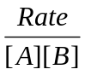 = 8.68 x 10⁻² mol⁻¹ dm³ min⁻¹
 | (d) | Suggest a change in condition to increase the amount of D collected.
 |  | Increase temperature / increase [A] / increase [B] / decrease [C]
4 | (a) | The following compound, compound F, was synthesised from benzene through a series of reactions.  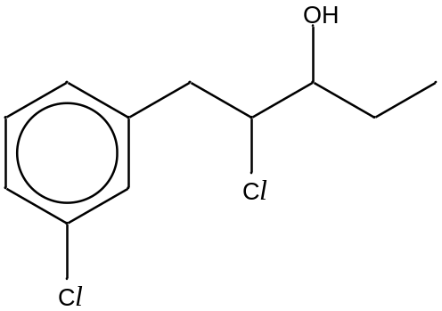  a  b  compound F  Identify two different functional groups present in the compound.
- chlorobenezene
- secondary chloroalkane
- secondary alcohol
- benzene
 | (b) | In the table below, write down the type of hybridisation expected, the bond angles a and b, and give a sketch of a hybrid orbital exhibited by each of the respective carbon.

Carbon | type of hybridization | bond angle | sketch of a hybrid orbital
marked with a | sp² | 120º | dumb-bell shape, with one lobe as a circle
marked with b | sp³ | 109.5º | dumb-bell shape, with one lobe as a circle, the other lobe must be thinner than the one above

 | (c) | During the synthesis of the compound F, a by-product, compound G, was formed.  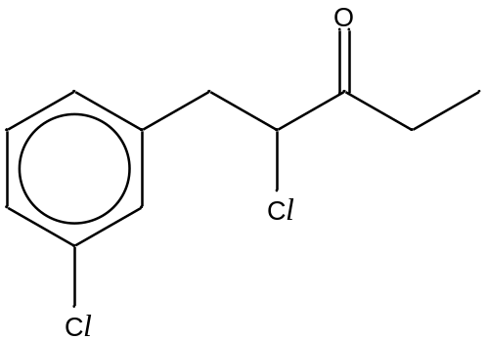  compound G  Suggest a simple chemical test to distinguish between compounds F and G. State the reagents and conditions needed, the observations that you would make, and write a balanced equation for the positive test.
Possible answers
Using 2,4-dinitrophenylhydrazine, warm
the ketone would form an orange precipitate, but the alcohol would not
OR
using hot acidified potassium dichromate
the alcohol would turn the dichromate from orange to green, but the ketone would not

AND
Balanced equation
5 | (a) | Complete the reaction scheme below by writing the structural formulae of the organic compounds H – L and stating the reagents and conditions needed for Steps I, II and III in the following tables.
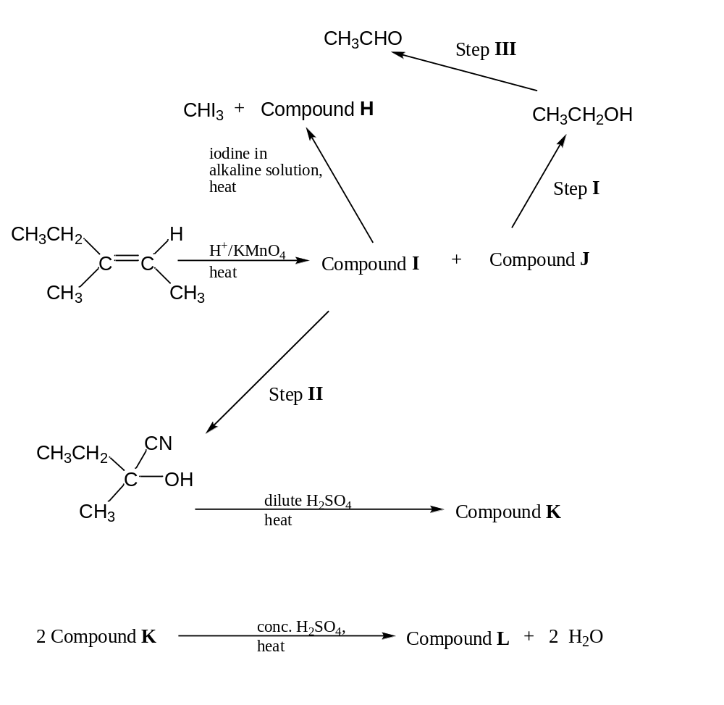
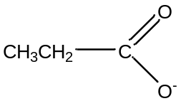 | 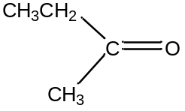
Compound H | Compound I
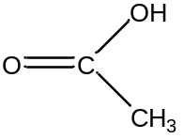 | 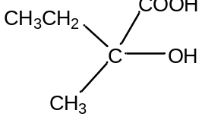
Compound J | Compound K
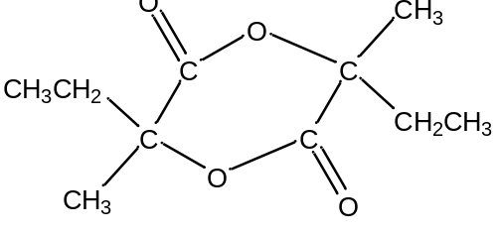
Compound L

Step | Reagent | Condition
I | LiAlH₄ | dry ether
II | HCN | trace amount of NaOH / NaCN, 10 – 20 ºC
III | acidified K₂Cr₂O₇ | heat and distill

 | (b) | Compound K, upon dehydration with excess concentrated sulfuric acid at 180 ºC, produces 3 different organic isomers M, N, and O. Isomer M is a structural isomer of isomers N and O.
 |  | (i) | Draw the displayed formulae of isomers M, N, and O.
 |  |  | 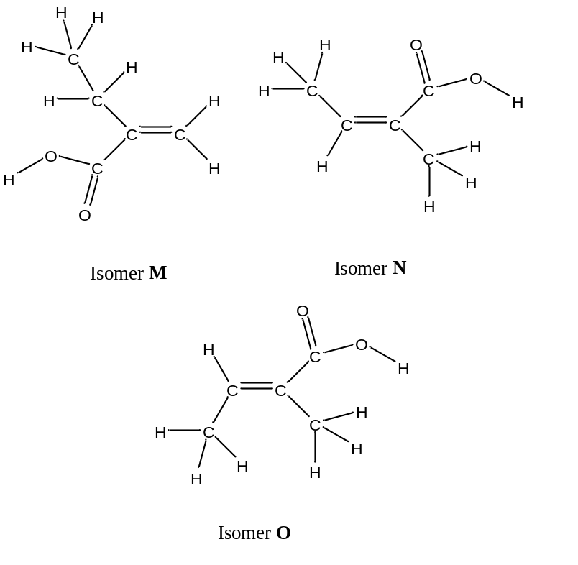
 |  | (ii) | Using your structures of isomers N and O, suggest and explain which has the higher boiling point
- isomer O has the higher boiling point
- more polar as compared to isomer N

Section B

6 | (a) | A student wants to identify an unknown Group I metal, P, within a sample of hydrogen carbonate, PHCO₃. After doing some research, she found a decomposition reaction that would suit her purpose. The decomposition reaction is shown as:  2 PHCO₃(s) → P₂CO₃(aq) + H₂O(l) + CO₂(g)  She heated a 5.00 g sample of PHCO₃ in a boiling tube, and bubbled the gas evolved into a solution of calcium hydroxide (concentration 1.0 mol dm⁻³). A white precipitate formed was found to have a mass of 1.70 g. Calculate the molar mass of PHCO₃ and hence identify P.
Ca(OH)₂ + CO₂ → CaCO₃ + H₂O
1.70 g of CaCO₃ = 0.016983 mol
amount of CO₂ present = 0.016983 mol
amount of PHCO₃ present = 0.033966 mol
molar mass of PHCO₃ = 147.2 g mol⁻¹
relative atomic mass of P = 86.2
Identify of P is Rb.
 | (b) | A standard solution of propanoic acid was made by pipetting 20.0 cm³ of propanoic acid, labelled solution Q, which was then made up to 250 cm³ with deionised water (labelled solution R). Solution R was then used to react with solid PHCO₃. It was determined that 34.50 cm³ of solution R was needed to react with 0.293 g of solid PHCO₃ completely. Calculate the concentration of propanoic acid in solution Q.
PHCO₃ + CH₃CH₂COOH → CH₃CH₂COO–P⁺ + H₂O + CO₂
amount of PHCO₃ present = 0.002 mol
amount of propanoic acid present in 34.50 cm³ of solution R =
0.002 mol
amount of propanoic acid present in 20.0 cm³ of solution Q =
0.014493 mol
[propanoic acid] = 0.72464 = 0.725 mol dm⁻³ (3 s.f.)
 | (c) | Given that solution Q contains only propanoic acid and its pH was 2.50 under room temperature and pressure (r.t.p.) conditions, calculate the acid dissociation constant of propanoic acid.
[H⁺] = 10^{-2.5} mol dm⁻³
K_{a} = 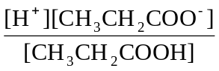
= 1.38 x 10⁻⁵ mol dm⁻³
 | (d) | Both propanoic acid and butan-1-ol have the same relative molecular mass, but have different pH values when the same amount was dissolved in 1 dm³ of solution. Explain, with the aid of relevant equations, which would have a lower pH value.
pH is a measure of H+ concentration in water.
CH₃CH₂COO⁻ is a more stable anion, as it would delocalise the negative charge over 3 centers, forming a resonance structure, but CH₃CH₂CH₂O⁻ is unable to do so. Hence propanoic acid would form a stronger acid as compared to butan-1-ol and hence a lower pH .
 | (e) | Butan-1-ol, with a molecular formula of C₄H₁₀O, can be converted into its various structural, positional and functional isomers through the aid of a catalyst and heat. A sample of butan-1-ol was heated to form 2 different structural isomers (compounds S and T).  Compound S can decolourise hot acidified potassium manganate(VII) solution. The oxidised product, labelled compound U, could form an orange precipitate with 2,4-dinitrophenylhydrazine solution.  A single isomer C₄H₉OCl was formed when compound T when reacted with a limited supply of chlorine gas under intense light.
 |  | (i) | Identify and draw the displayed formulae of compounds S, T and U.

Information | Deduction
Compound S can decolourise hot acidified potassium manganate (VII) solution. | - Can be oxidised  - Primary or secondary alcohol
The oxidised product, labeled compound U, could form orange precipitate with 2,4-dinitrophenylhydrazine solution. | - Condensation reaction  - Product is a ketone
A single isomer C₄H₉OCl was formed when compound T when reacted with a limited supply of chlorine gas under intense light. | - Substitution reaction  - All H are in the same chemical background.

Structure of S | Structure of T | Structure of U
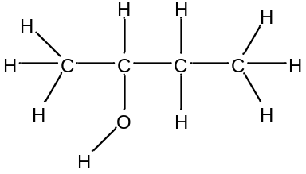 | 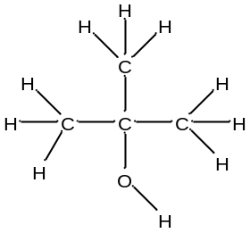 | 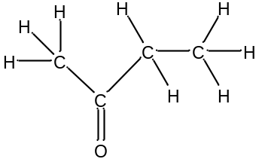

 |  | (ii) | State the observations that could be made and illustrate your answer with the aid of balanced equations, when
 |  |  | I | compound S was added with hot alkaline iodine solution;
Yellow precipitate will form
CH₃CH(OH)CH₂CH₃ + 4I₂ + 6OH⁻ →
CH₃CH₂COO⁻ + CHI₃ + 5NaI + 5H₂O
 |  |  | II | compound T was added to PCl₅ at room temperature and pressure conditions; and
white fumes will be formed
(CH₃)₃COH + PCl₅ → (CH₃)₃CCl + POCl₃ + HCl
 |  |  | III | butanal, an oxidised product from butan-1-ol, was added with hot Fehling’s solution.
Brick red precipitate will be formed
CH₃CH₂CH₂CHO + 2Cu²⁺ + 5OH⁻ →
CH₃CH₂CH₂COO⁻ + Cu₂O + 3H₂O
7 | (a) | Aluminium chloride is used as a catalyst in organic chemistry. Use dot-and-cross diagrams to illustrate the structures of aluminium chloride and its dimer, Al₂Cl₆, and state the shapes and bond angles around the aluminium atom(s) in each structure.
 |  |  | 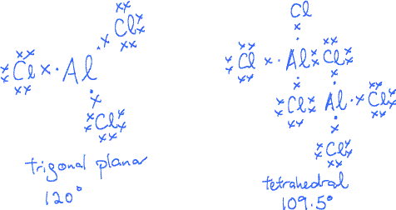
 | (b) | The reaction between gaseous chlorine and benzene is catalysed by the presence of AlCl₃. Describe, with the aid of a balanced equation, why the reaction would not likely take place when aqueous chlorine was used instead.
 |  | The catalyst would be hydrolysed and not present to lower the activation energy of the reaction, thus resulting in a kinetically unfavourable reaction.
 | (c) | Another commonly used catalyst for this reaction is FeCl₃ and it exists as various isotopes such as ⁵⁴FeCl₃ and ⁵⁶FeCl₃. Write the electronic configuration of Fe in ⁵⁶FeCl₃.
 |  | 1s² 2s² 2p⁶ 3s² 3p⁶ 3d⁵
 | (d) | A student investigated the kinetics of the reaction between FeCl₃, Cl₂ and benzoic acid and the following information was obtained.

Experiment No. | [FeCl₃]  / mol dm⁻³ | [Cl₂] / mol dm⁻³ | [benzoic acid]  / mol dm⁻³ | Rate  / mol dm⁻³ min⁻¹
1 | 0.100 | 0.075 | 0.250 | 1.39 x 10⁻⁵
2 | 0.100 | 0.100 | 0.250 | 1.85 x 10⁻⁵
3 | 0.150 | 0.075 | 0.300 | 2.50 x 10⁻⁵
4 | 0.150 | 0.100 | 0.250 | 2.78 x 10⁻⁵

 |  | (i) | Determine the order of reaction with respect to FeCl₃, Cl₂, and benzoic acid. Hence write the rate equation and determine the rate constant of the reaction using information from experiment 3.
Comparing experiments 1 and 2,
- [Cl₂] increase by 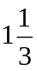times while rate increases by times
- order w.r.t. [Cl₂] is 1.
Comparing experiments 2 and 4,
- [FeCl₃] increase by 1.5 times while rate increases by 1.5 times
- order w.r.t. [FeCl₃] is 1.
Comparing experiments 3 and 4,
- [Cl₂] increase by times and [benzoic acid] decrease by 1.2 times, while rate increases by X times
- order w.r.t. [benzoic acid] is 1.
Rate = k [FeCl₃] [Cl₂] [benzoic acid]
k = 7.41 x 10⁻³ mol⁻¹ dm³ min⁻¹

 |  | (ii) | Sketch a labelled energy profile diagram for this reaction.
 |  |  | 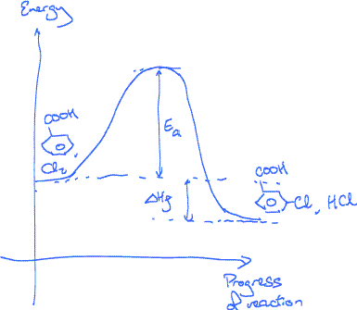
 | (e) | Suggest reagents and conditions for the 4-step synthesis of 3-oxo-butanoic acid from propene.
 |  |  | 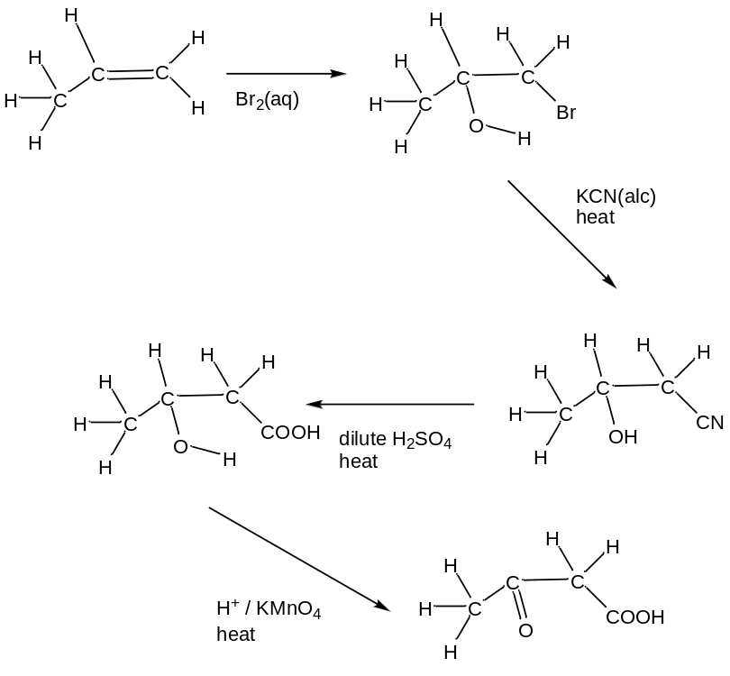
8 | (a) | Sulfur, S₈, in its yellow solid state, exists in a variety of oxidation states in its compounds. One of them is that of sulfur dioxide, which is readily formed during a volcanic eruption or during the combustion of fossil fuels. Using the relevant information from the Data Booklet, and given the following data, calculate the bond energy of S=O in sulfur dioxide.  S₈(s) → S₈(g) ∆Hº = +120 kJ mol⁻¹  ∆H_{f}(SO₂(g)) = –296 kJ mol⁻¹
S₈ (g) + O₂(g) → SO₂(g)
bonds to be broken – 1 S-S and 1 O=O: 264 + 496 = 760 kJ
bonds to be formed – 2 S=O = 2x kJ
enthalpy change of reaction
= sublimation of sulfur + bonds to be broken – bonds to be formed
-296 = 1/8 x (+120) + 760 – 2x
x = +535.5 kJ mol⁻¹ (536 – 3 s.f.)
 | (b) | The key reaction during the Contact process, for manufacturing sulfuric acid, is as follows:  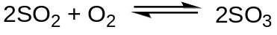  A 3 dm³ vessel was used and 4 moles of sulfur dioxide and 4 moles of oxygen were introduced into the vessel. Given that the exothermic reaction, under the conditions of 450 ºC, 2 atm pressure and presence of vanadium(V) oxide, ensured a 96% conversion, calculate the K_{c} of the reaction.
amount of sulfur dioxide at equilibrium = 0.04 x 4 = 0.16 mol
amount of oxygen at equilibrium = 4 – 0.5 * (4 – 0.16) = 2.08 mol
amount of sulfur trioxide at equilibrium = 0.96 x 4 = 3.84 mol
K_{c} = 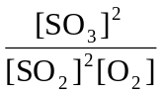 = 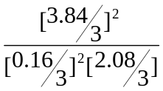= 830 mol⁻¹ dm³
 | (c) | Predict and explain the changes to the yield and the K_{c} value if the following changes were made:
 |  | (i) | temperature was reset to 200 ºC; and
temperature was lowered
- system favors the exothermic reaction
- heat given off to counteract the drop in temperature
- equilibrium shifts to the right
- both k_{f} and k_{b} decreases
- but k_{f} decrease by a lesser extent
- K_{c} value increases
 |  | (ii) | 2 moles of SO₂ were added.
additional moles of reactants was added
- system tries to remove the additional reactants, favoring the formation of more products
- equilibrium shifts to the right
- K_{c} value remains unchanged
- K_{c} dependent on temperature only
 | (d) | A 25 cm³ portion of the equilibrium mixture in the above part was extracted and dissolved in 1 dm³ of distilled water, forming a mixture labelled as mixture V. Given that sulfurous acid, H₂SO₃, is a weak dibasic acid, calculate the volume of 1.5 mol dm⁻³ sodium hydroxide solution required to completely neutralise the mixture V and suggest a possible indicator to be used.
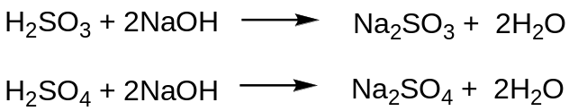
amount of SO₂ present = 25 / 3000 x 0.16 mol = 1.3333 x 10⁻³ mol
amount of SO₂ present = 25 / 3000 x 3.84 mol = 0.032 mol amount of NaOH needed = (0.032 + 1.3333 x 10⁻³) x 2 = 0.066667 mol
volume of NaOH used = 0.066667 / 1.5 = 0.0444 dm³ = 44.4 cm³ possible indicators – phenolphthalein
 | (e) | Suggest a chemical test to distinguish the compounds in each of the following pairs, stating clearly all observations and balanced equations for positive tests.

 | Compound W | Compound X
(i) | 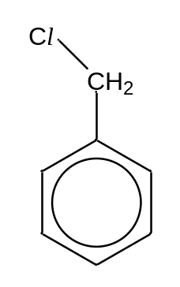 | 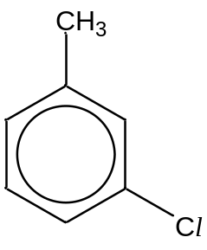

ethanolic silver nitrate / aq NaOH, heat, acidify followed by AgNO₃.
Compound W will form a white precipitate while Compound X will not form a white precipitate.
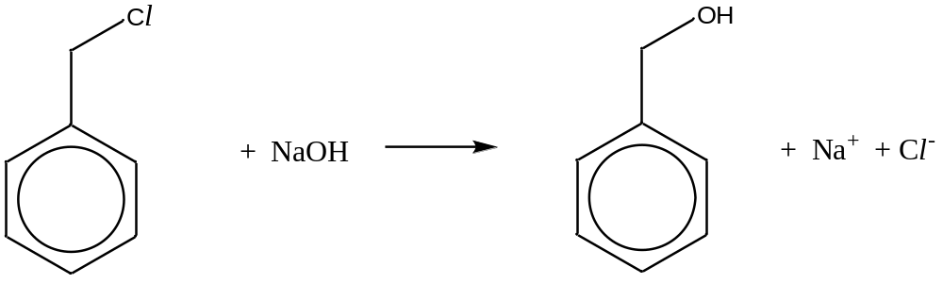

(ii) | 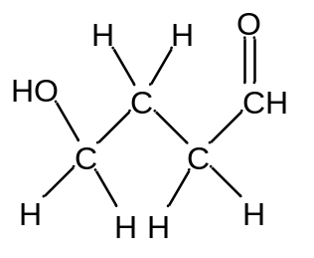 | 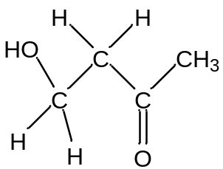

Iodine in alkaline solution, heat
Compound W will not form the yellow precipitate, but Compound X will form a yellow precipitate.
